Welcome to Airtext.

New releases of Phone APPs, Airtext Router firmware, and individual configurations will be created as new features are added to the Airtext System. Each Airtext system can be updated by the customer to take advantage of these new features. The phone and tablet apps are updated like any other app via the Google play store. New firmware and configurations can be loaded into the Airtext Router in about 5 minutes using your phone without removing or disconnecting any equipment, or moving the airplane out of the hangar. The Airtext APP you already have will pull the new files from the Airtext Servers and save them to your phone using Wi-Fi or your Cell phone data plan. Then those files can be sent from your phone to the Airtext Router using Bluetooth. The plane does not need to be out of the hangar to update these files.

Section I

If you have an Android tablet or phone that has the latest version Airtext application already installed then skip to section II. The current version is 2017.09.25 at the time of this writing. Many older versions of the Airtext App will work, but we highly recommend updating to the latest version to improve the firmware update speed and add features.

Airtext app can be found on the Google Play Store. It will be the one with our LOGO. The latest version will always be available in the play store. Install and launch just like any other app.

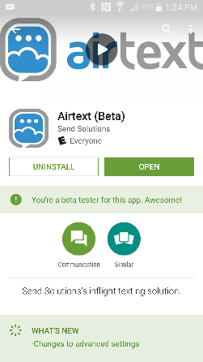
Section II

Open the app by selecting the Airtext Icon. Enable Bluetooth if asked.

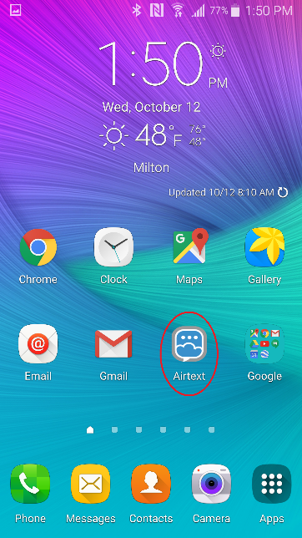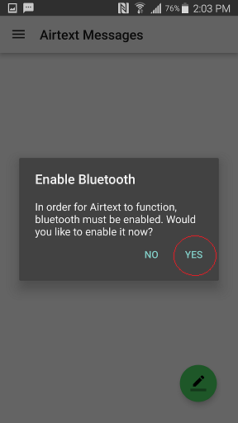

Input a User Name such as “Joe Smith” if asked to do so. The User Name you enter here will be the name that ground users will see when they receive a text from you via the Airtext system. Step through all of the welcome screens if they show up.

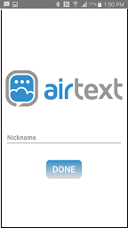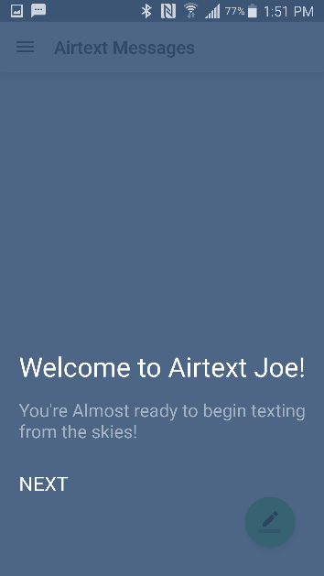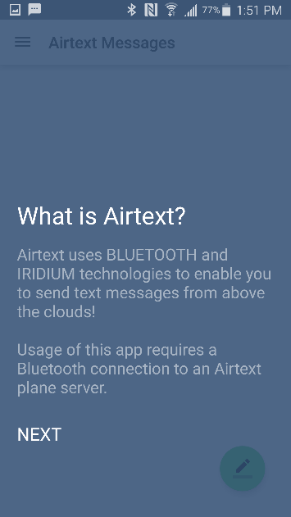

Select the Menu system on the upper right corner. It is indicated with the three lines.

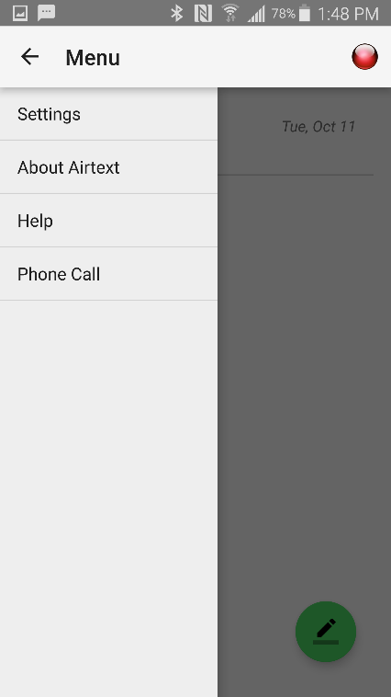

Select the Settings menu, then scroll to the bottom and select "Advanced Settings". Then select “Program Router Firmware”

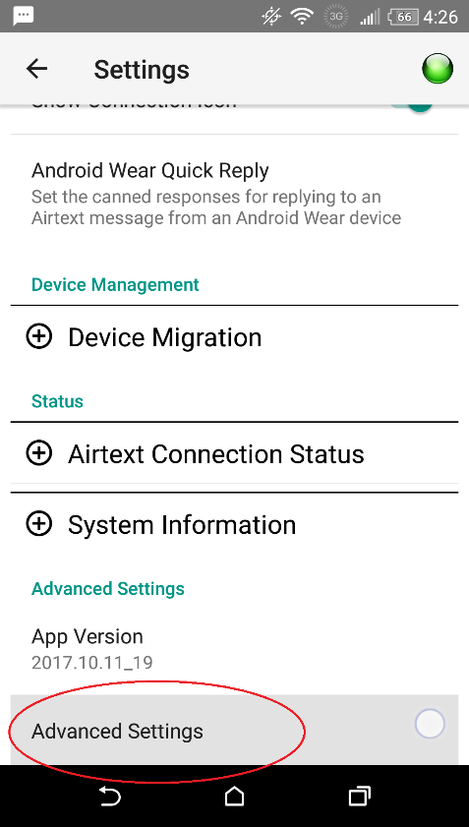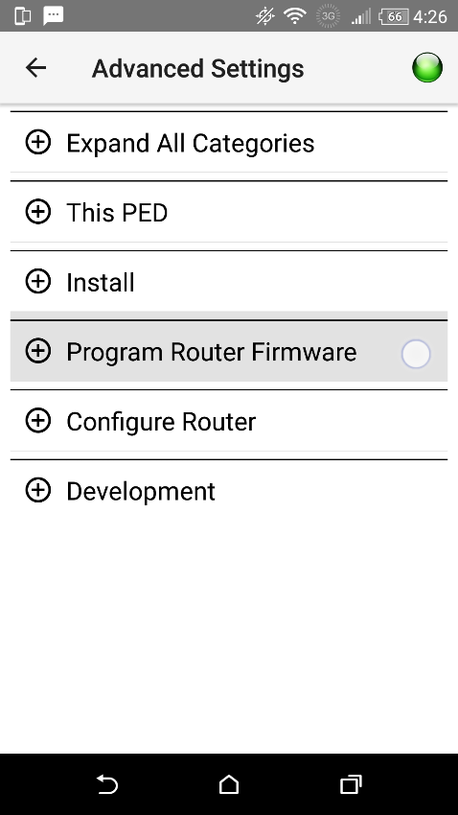

You will be asked to enter a password to "Unlock Potentially Dangerous Settings"
To bypass this password, perform a "long press" on the text entry field.
Five dots should appear. Tap "Unlock"

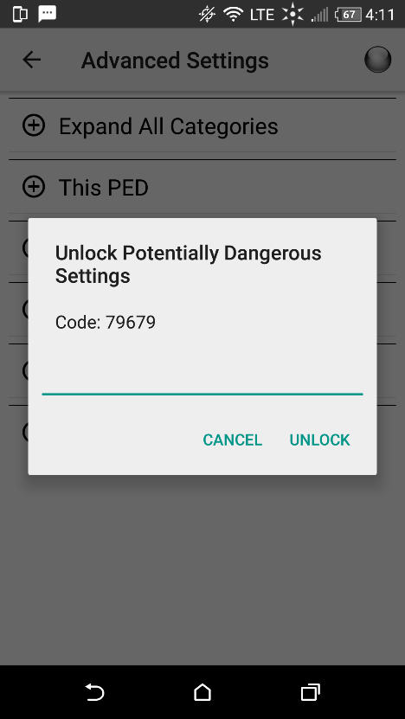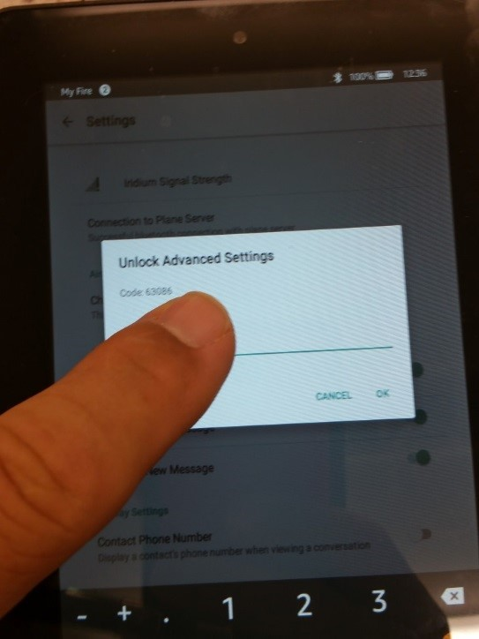

"The "Program Router Firmware" options should now be accessible"

Power up the Airtext Router if not already on. Check for the Green dot to ensure that the phone is connected to the Airtext Router via Bluetooth.
Open "Program Router Firmware" and then “Get Firmware Id”. This proves that the Bluetooth Link is operating by showing the (older) version of firmware that is currently installed on the Airtext Router.

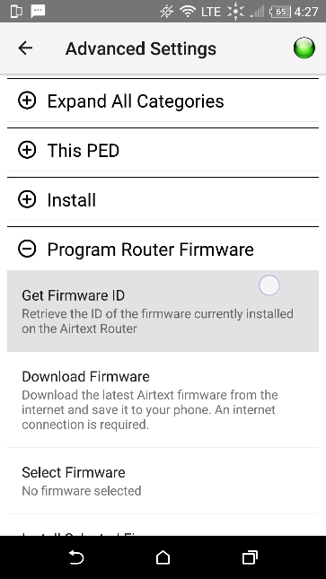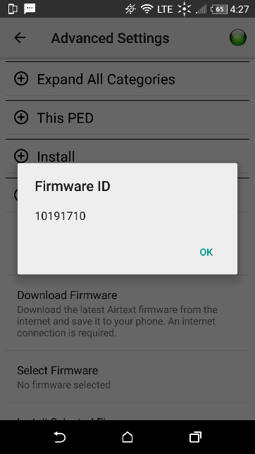

Tap "Download Firmware". Select "Main Branch" unless otherwise instructed by Send Solutions Staff.
At the time of this writing the version is 10191710. Newer versions or multiple versions may be available. If more than one is available, then select the newest. The name is in the Month/Day/year/hour format. Make your selection and press OK. It loads in just a few seconds.
Then Tap “Select Firmware”. This will select from all of the firmware versions that you might have on your phone.

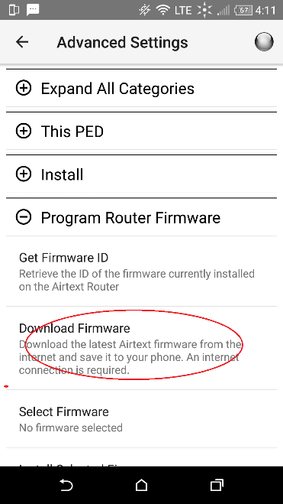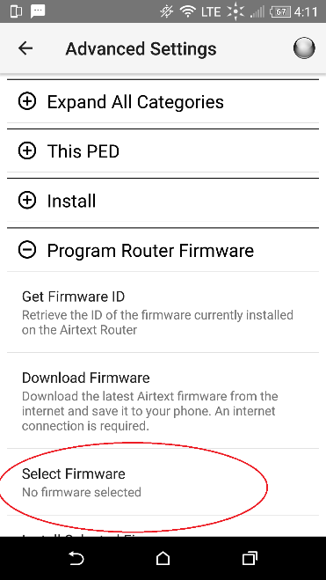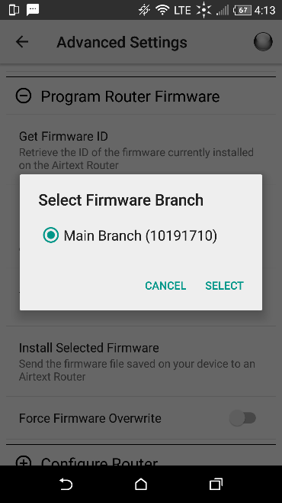

Tap "Install Selected Firmware".
You will be prompted to verify the firmware installation, tap OK.

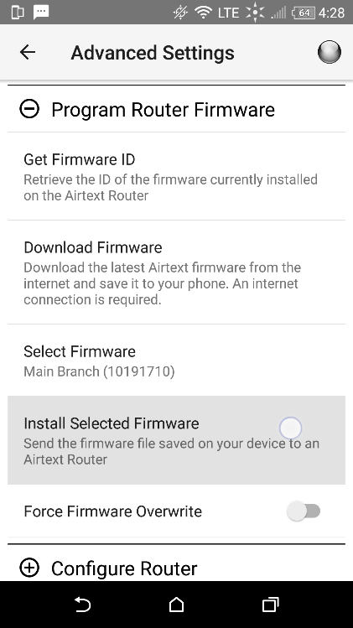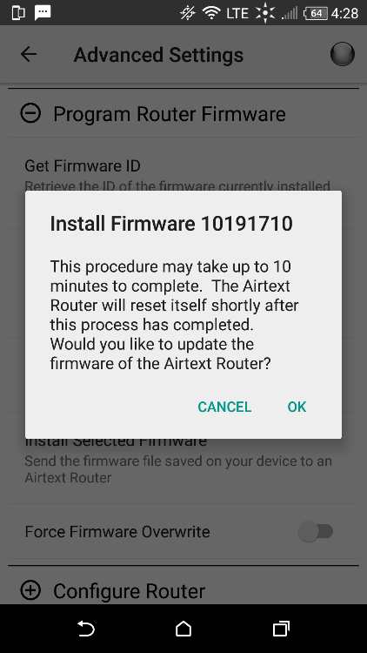
A dialog window will show the installation progress. Then a window will be displayed to indicate that the firmware installation has completed.

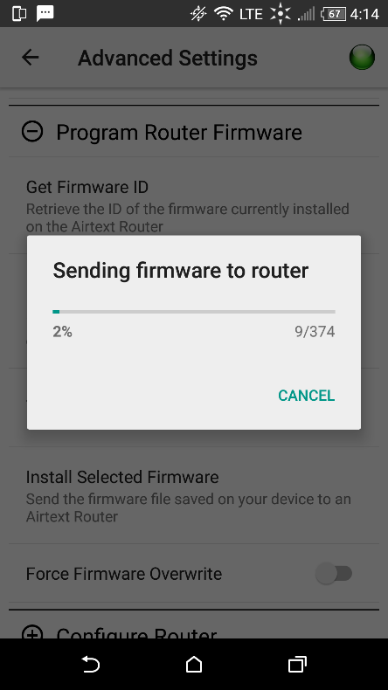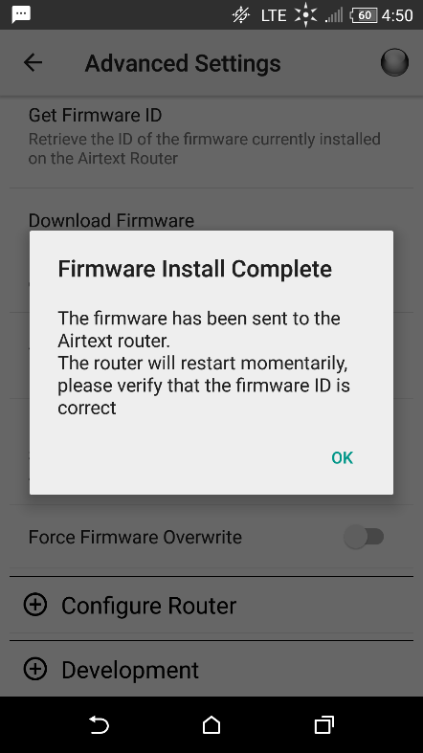
Note: Some Android phones and tablets sleep if no activity is detected on the screen while running on battery power. You can touch the screen every minute or so or connect to a charger to keep it awake. The firmware update process continues during sleep, but it may run at half speed.

Section III

It is usually a good idea to also check for a new configuration each time you update firmware.
It is pretty much the same process as updating firmware. Configurations are smaller so they transfer much faster. Go back one screen in the menu and then select “Configure Router”. Then select “Get Configuration from the Internet”.

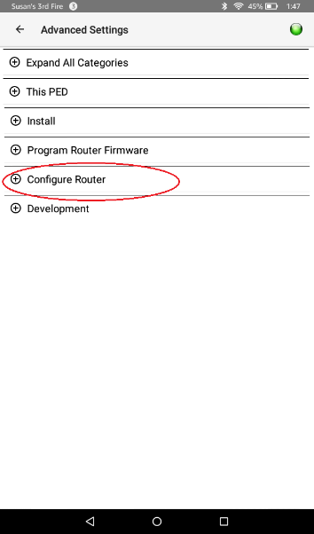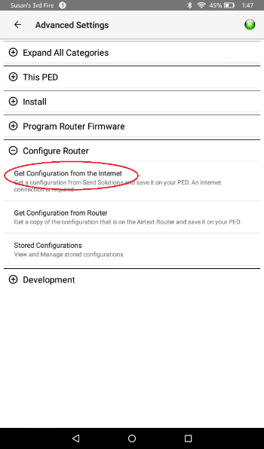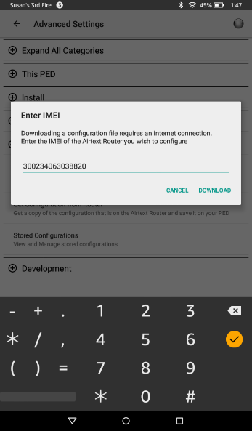

If you are in-range of the Airtext Router you wish to update, the Routers IMEI (Satellite network ID) will be pre-filled. If not then carefully enter the IMEI of the Airtext Router you wish to update. This number can be found on a label on the back of the Airtext Router or on the documentation supplied at the time of shipment. The configuration that was created for each individual Airtext Router is identified by the correct IMEI number. The IMEI number determines which configuration is pulled from our Servers.

Note: If you are updating more than one Airtext Router, then make sure the IMEI matches the Airtext Router that you are updating, not the last one you updated.

Once you are sure the correct IMEI number is listed, select “Download”.

The configuration will load from the internet about one second and then be displayed. Select “Send to Airtext Router”. File transfer progress is indicated with the “Write File” block counter.

Note: Ensure that some form of configuration is visible in the greyed portion of the screen. If the screen is completely blank then verify the IMEI number and download again.

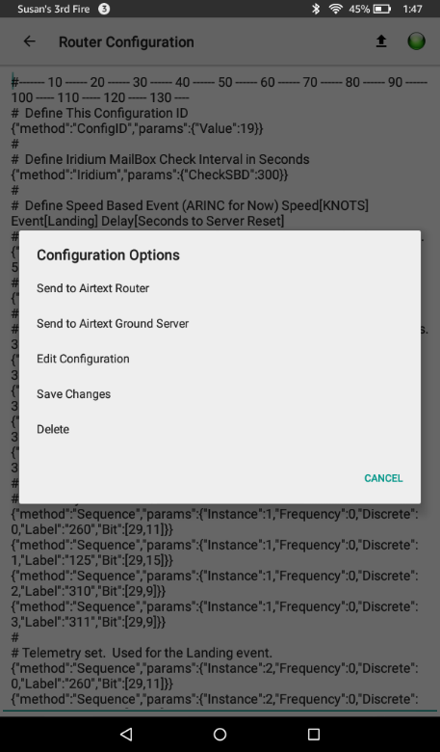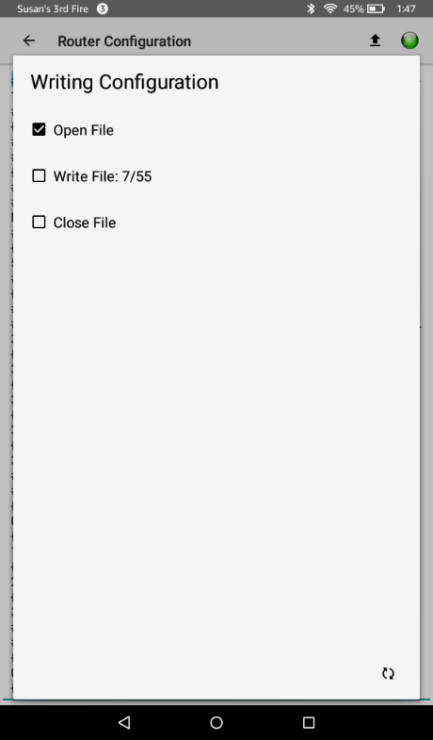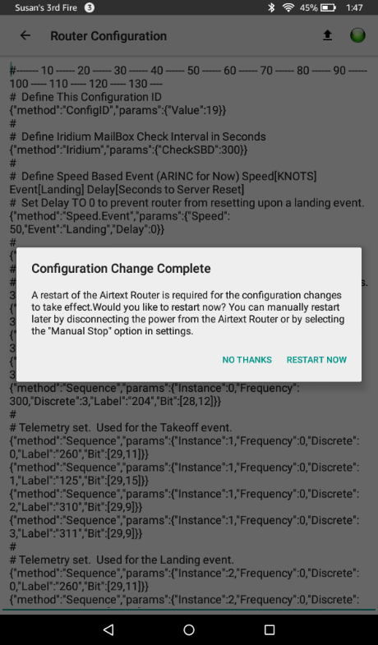

Take some care during this step not to inadvertently change the configuration. Deleting a character or adding a character in active lines will cause indeterminate behavior.

The new configuration transfers in 10 to 20 seconds depending on its complexity. After transfer, the update process is fully complete. The Airtext Router will reset, and then be ready for use.

Although it is possible to modify the configuration in the field, it is recommended for new users to be on the phone with a member of the Airtext Technical staff during that process.

