**Welcome to Airtext.**

New releases of Phone APPs, Airtext Router firmware, and individual configurations will be created as new features are added to the Airtext System. Each Airtext system can be updated by the customer to take advantage of these new features. The phone and tablet apps are updated like any other app via the Apple APP store. New firmware and configurations can be loaded into the Airtext Router using your phone without removing or disconnecting any equipment in about 5 minutes. The Airtext APP you already have will pull the new files from the Airtext Servers and save them to your phone using Wi-Fi or your Cell phone data plan. Then those files can be sent from your phone to the Airtext Router using Bluetooth. The plane does not need to be out of the hangar to update these files.

**Section I**

If you have an Apple iOS tablet or phone that has the latest version Airtext application already installed then skip to section II. The current version is 3.3.6 at the time of this writing. Many older versions of the Airtext App will work, but we highly recommend updating to the latest version to improve the firmware update speed and add features.

Airtext app can be found on the Apple App Store. It will be the one with our LOGO. The latest version will always be available in the app store. Install or update and then launch just like any other app.

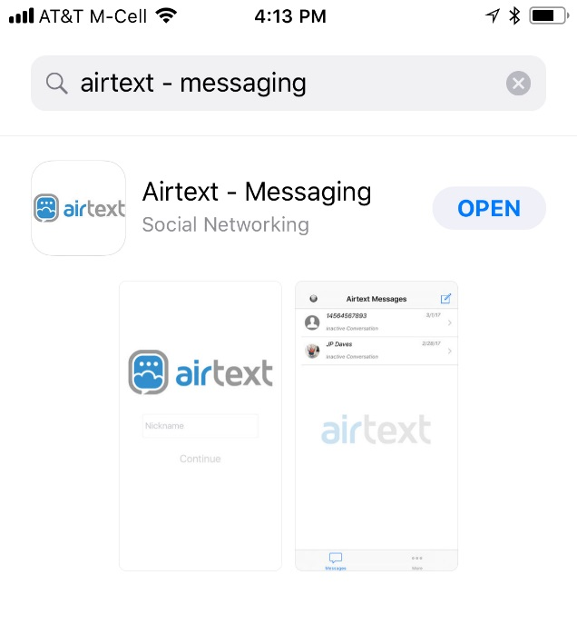

**Section II**

Open the app by selecting the Airtext Icon.

Enable Bluetooth if asked.

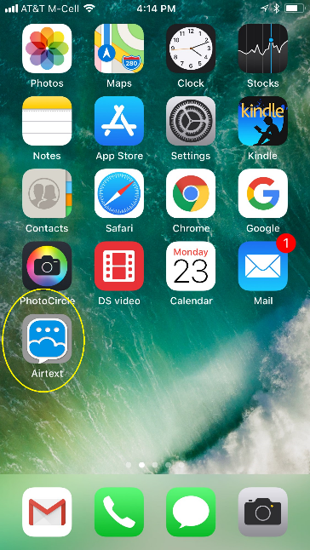 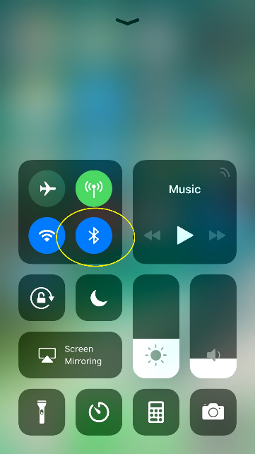

Input a User Name such as “Joe Smith” if asked to do so. The User Name you enter here will be the name that ground users will see when they receive a text from you via the Airtext system. Step through all of the welcome screens if they show up.

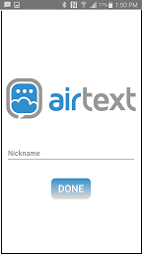 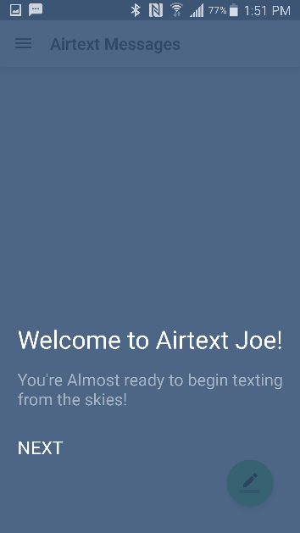 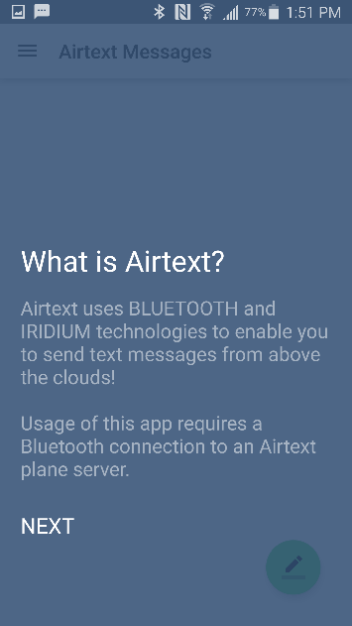

Select the More section in the bottom right corner. It is indicated with the three dots.

Then select “Advanced Settings”, then select “Program Router Firmware”

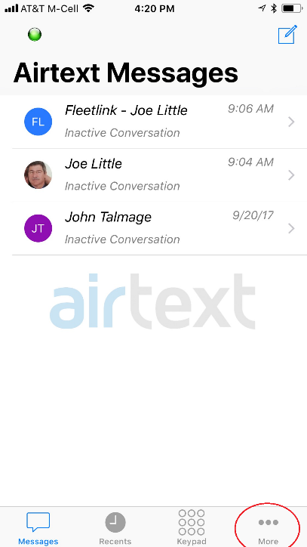 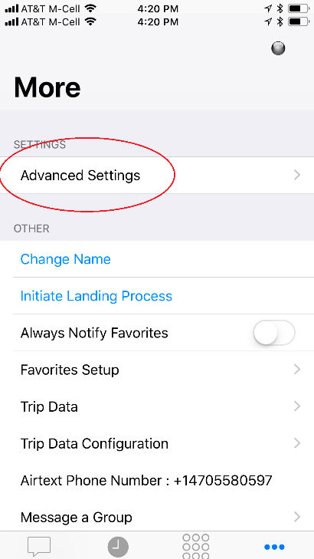 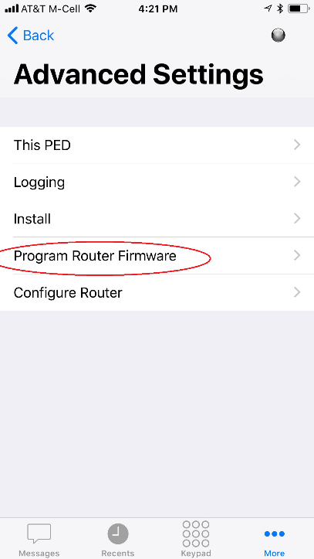

Once selected, the app will ask for a password.

A light press on the password window will let you bypass the password. It will pop up a paste box. Use it to paste the password into the window and then press OK.

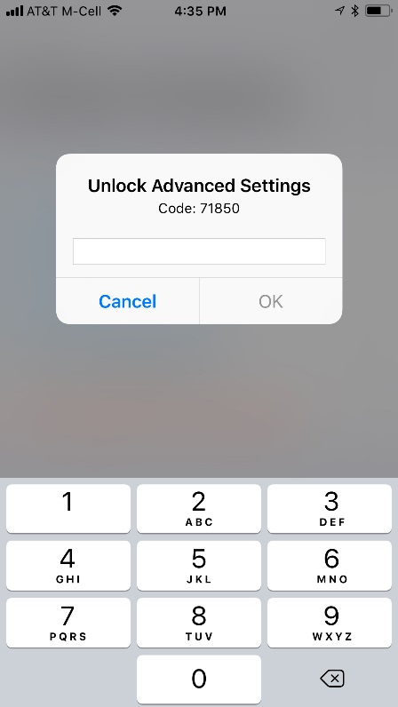  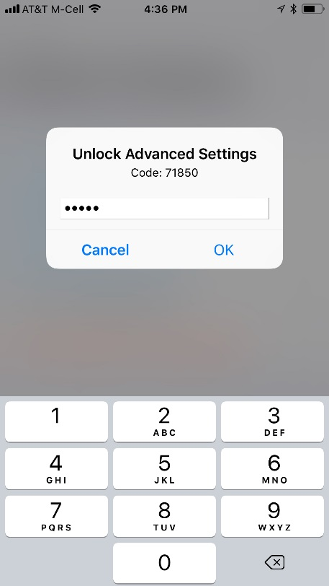

Just to reduce confusion, perform “Delete Stored Firmware Downloads”. This erases any older versions that may be left over from previous updates.

Download Firmware from Internet. Select "Main Branch" unless otherwise instructed by Send Solutions Staff. This pulls the latest version of firmware from the Airtext Servers and saves it on your phone. At the time of this writing the version is 10191710. Newer versions or multiple versions may be available. If more than one is available, then select the newest. The name is in the Month/Day/year/hour format. Make your selection and press OK. It loads in just a few seconds.

Then Select Firmware. If you deleted all the old downloads then select the only one listed.

Power up the Airtext Router if not already on, wait for the Green Dot that indicates Bluetooth LE connection is active, and then use the “Install selected Firmware”. This process takes about 3 minutes. If the progress bar moves slowly, then move around the cabin to find a location that has a perfect Bluetooth connection.

 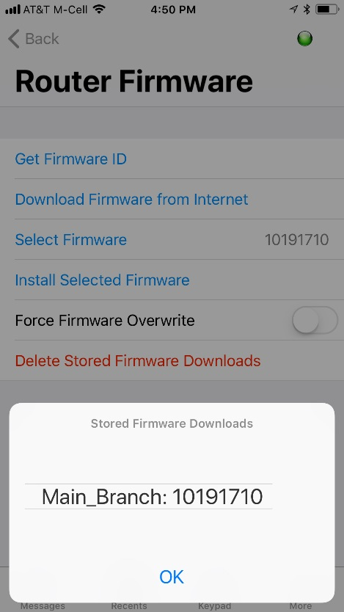

The progress bar will let you know when the firmware update is complete and indicate Success.

If you are not present when the progress bar disappears, then you can use the “Get Firmware ID” button to inquire that info from the router. If that name matches the name of the firmware you just loaded then you know that the update was successful.

**Section III**

It is usually a good idea to also check for a new configuration each time you update firmware.

It is pretty much the same process as updating firmware. Configurations are smaller so they transfer much faster. Go back one screen in the menu and then select Configure Router.

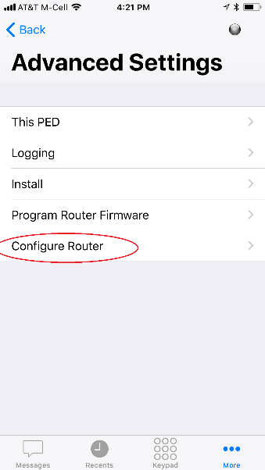

If you are in-range of the Airtext Router you wish to update, the Routers IMEI (Satellite network ID) will be pre-filled. If not then carefully enter the IMEI of the Airtext Router you wish to update. This number can be found on a label on the back of the Airtext Router, or on the documentation supplied at the time of shipment.

The configuration will load in about one second then be displayed. Press the upload button in the top right corner then select “Send to Airtext Router”.

Note: Ensure that some form of configuration is obtained. If the screen is completely blank then verify the IMEI number and download again.

Note: Take reasonable care not to change the configuration. Deleting a character or adding a character in active lines will cause indeterminate behavior.

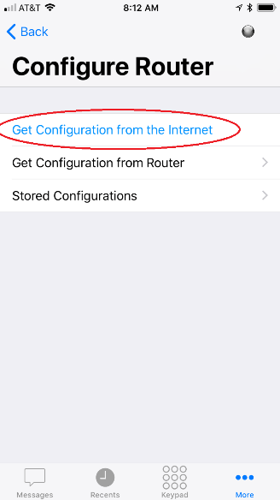 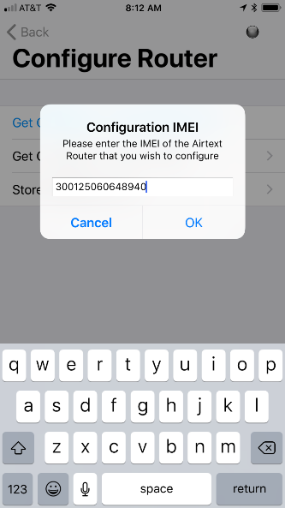 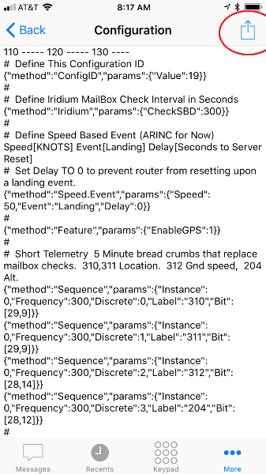

Take some care during this step not to inadvertently change the configuration.

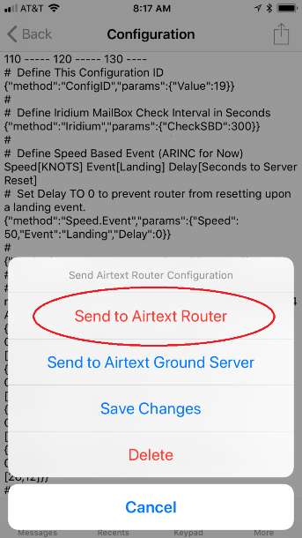 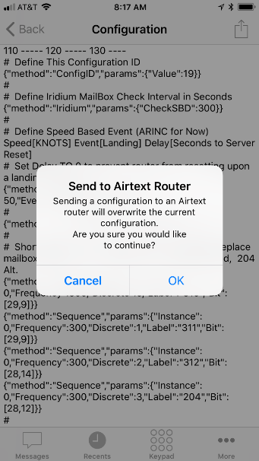 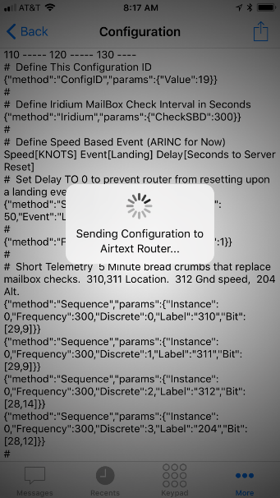 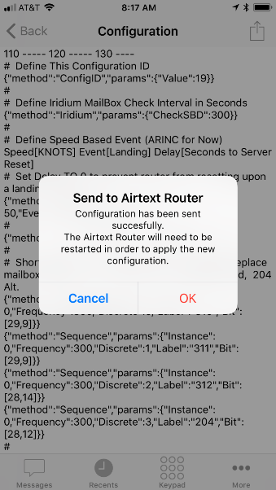

The new configuration transfers in 10 to 20 seconds depending on its complexity. After transfer, the update process is fully complete. The Airtext Router will reset, and then be ready for use.

Although it is possible to modify the configuration in the field, it is recommended for new users to be on the phone with a member of the Airtext Technical staff during that process.