BUSINESS AVIATION

FBO Link App Puts Wi-Fi To Work
by Matt Thurber
- February 11, 2018, 9:20 PM
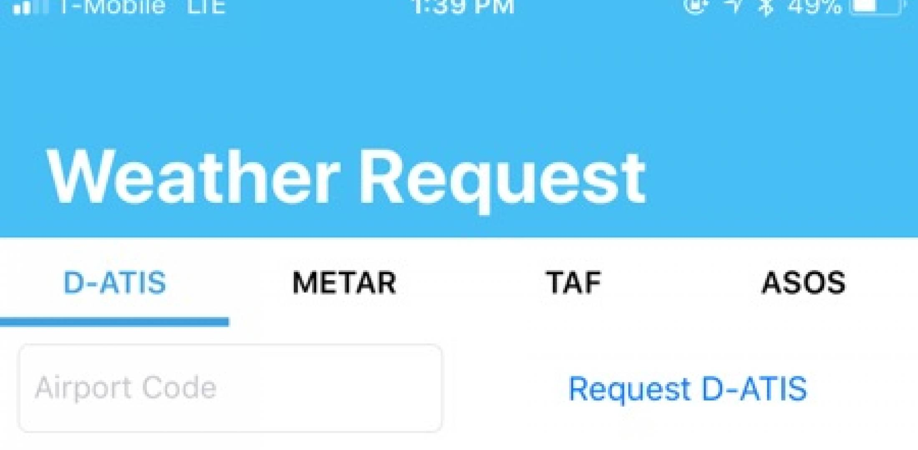
The free FBO Link app from Send Solutions provides a simple method to access D-ATIS in aircraft not equipped with the right kind of FMS.
Pilots flying aircraft with the right equipment have been simplifying cockpit operations for years, using their FMSs to make digital automatic terminal information service (D-ATIS) requests well before nearing a destination airport. Now with the new FBO Link app, pilots with access to airborne connectivity can request D-ATIS without a modern FMS or having to pay the subscription price for that capability.
FBO Link was developed by Send Solutions, which manufactures an Iridium connectivity system called Airtext, and the app does more than relay D-ATIS information. The app’s primary function is to let any aircraft with satcom or air-to-ground connectivity make requests to FBOs without having to call on the radio when in range of the destination airport. FBO Link also provides Metars, TAFs, and ASOS (automated surface observing system) information for airports worldwide. Regular ATIS and AWOS aren’t available over datalinks; there are currently 73 U.S. airports offering D-ATIS.
“FBO Link doesn’t have to work with just our equipment,” said David Gray, Send Solutions founder and CEO. “Why not make it for [other types]?”
Aircraft equipped with Airtext don’t need the FBO Link app, as the messaging system is a subset of the Airtext functions and can be accessed directly without the app.
To use FBO Link, the FBO connects a small USB device into the computer at the customer service desk. The device has a light that turns blue when a new text message is received from an FBO Link user. If the CSR doesn’t respond to the message right away, the light will flash blue and yellow. The CSR can respond to the pilot via text message and accept the pilot’s request, or ask any questions to clarify the request. When the link is active, the light remains green until a new request arrives.
FBO Link is free for Apple iOS and Google Android devices. FBOs that sign up with the FBO Link network pay $300 a year to participate. FBO Link launched with Wilson Air Center’s four FBOs as the beta testing sites, and Gray expects to add more FBOs now that FBO Link has launched, beginning with FBOs patronized by Airtext customers.

